Cloud Computing (Lab 13)
Name : Tooba Shafique
Reg no : 2023-BSE-065
BSE-V-B

LAB 13 – FULL FORMAT (Checklist)

TASK 0 – Lab Setup (Codespace & GH CLI)
Steps
- Create repository and Codespace
gh repo create CC_<YourName>_<YourRollNumber>/Lab13 --public
gh codespace create --repo <username>/Lab13
gh codespace list
gh codespace ssh -c <codespace_name>
Screenshots
task0_codespace_create_and_list.png
task0_codespace_ssh_connected.png

TASK 1 – Create IAM Group
Steps
mkdir -p ~/Lab13
cd ~/Lab13
touch main.tf
terraform init
terraform apply -auto-approve
terraform output
Screenshots
task1_project_directory.png
task1_file_created.png
task1_main_tf.png
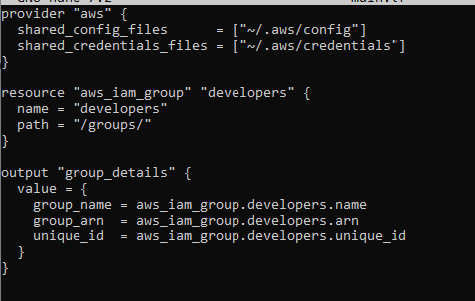
task1_terraform_init.png
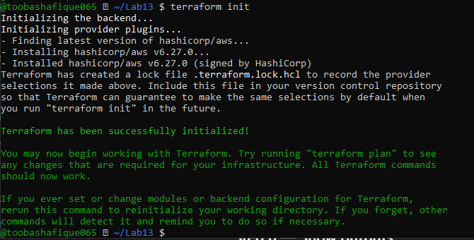
task1_terraform_apply.png
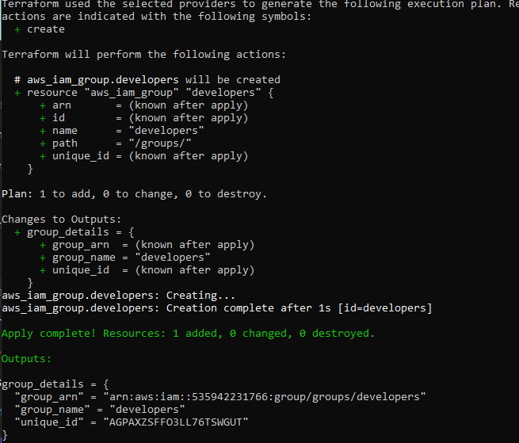
task1_terraform_output.png
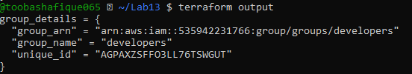
task1_aws_console_group.png
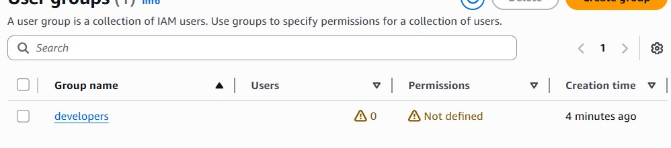

TASK 2 – Create IAM User
Screenshots
task2_main_tf_user.png
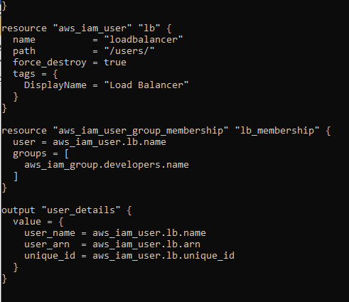
task2_terraform_apply.png
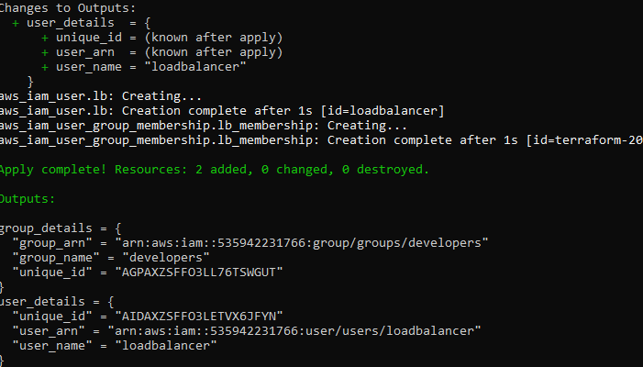
task2_terraform_output.png


task2_aws_console_user.png
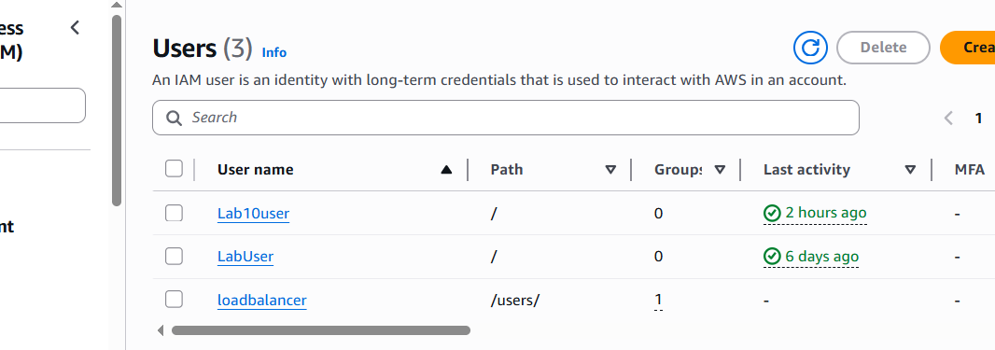
task2_aws_console_user_groups.png
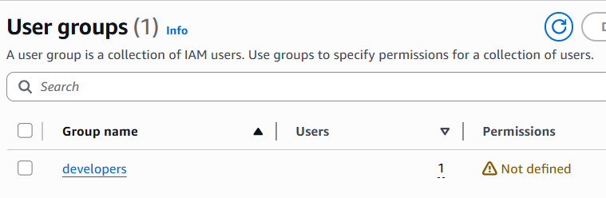

TASK 3 – Attach Policies
Screenshots
task3_main_tf_policies.png
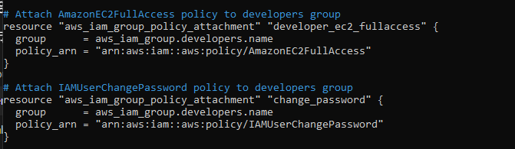
task3_terraform_apply.png
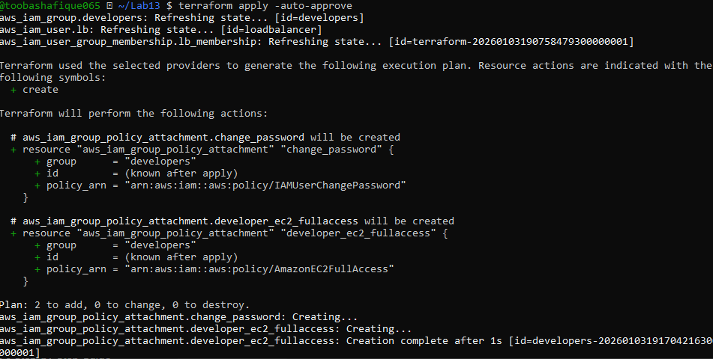

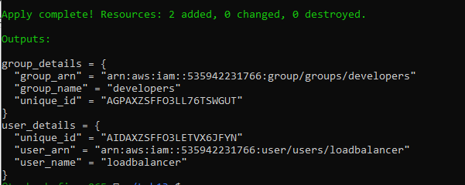
task3_aws_console_policies.png
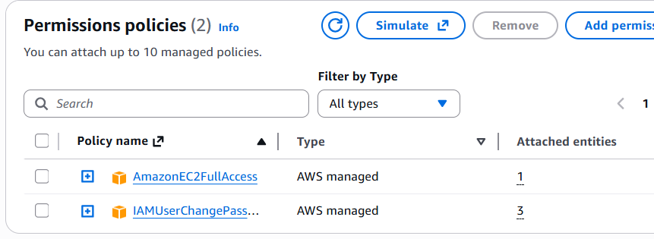

TASK 4 – Create Login Profile
Screenshots
task4_variables_tf.png
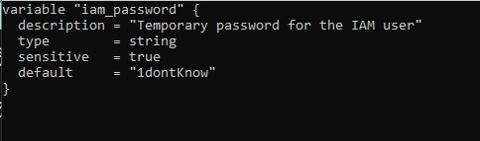
task4_create_login_script.png
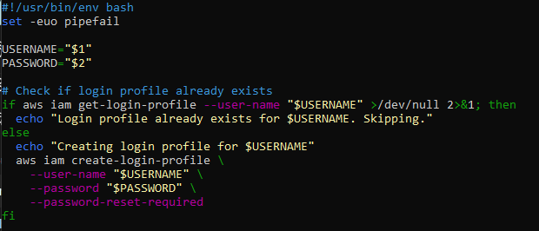
task4_chmod_script.png
task4_main_tf_login_profile.png
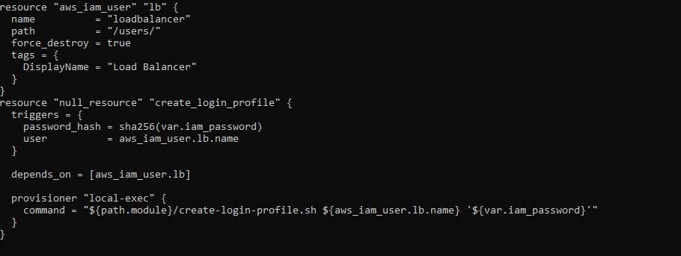
task4_terraform_apply.png
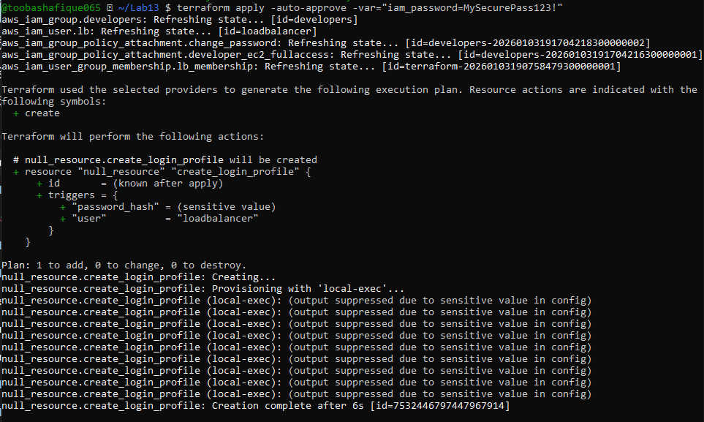
task4_aws_cli_verify.png
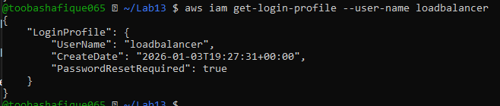
task4_aws_console_login.png
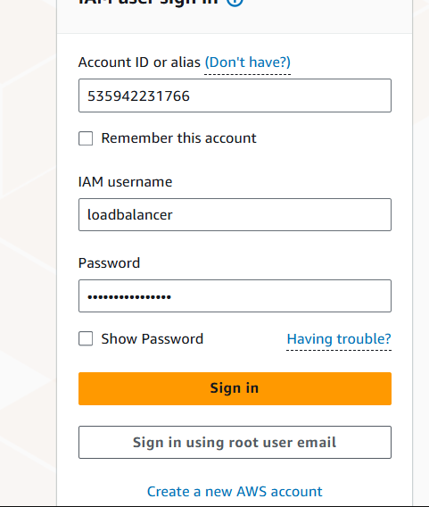
task4_aws_console_password_reset.png
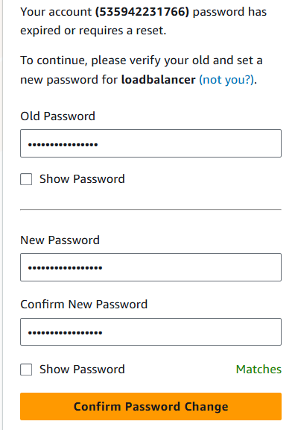
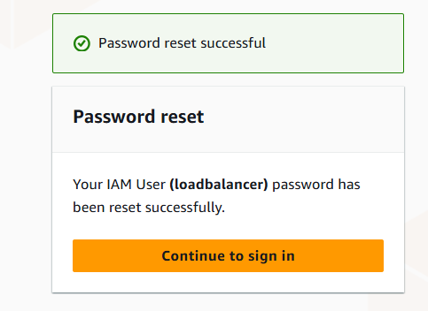

TASK 5 – Create Access Keys
Screenshots
task5_main_tf_access_keys.png
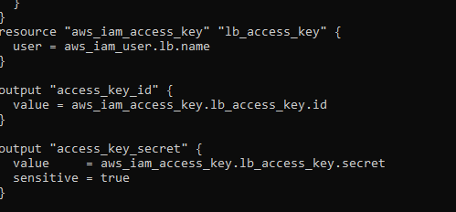
task5_terraform_apply.png
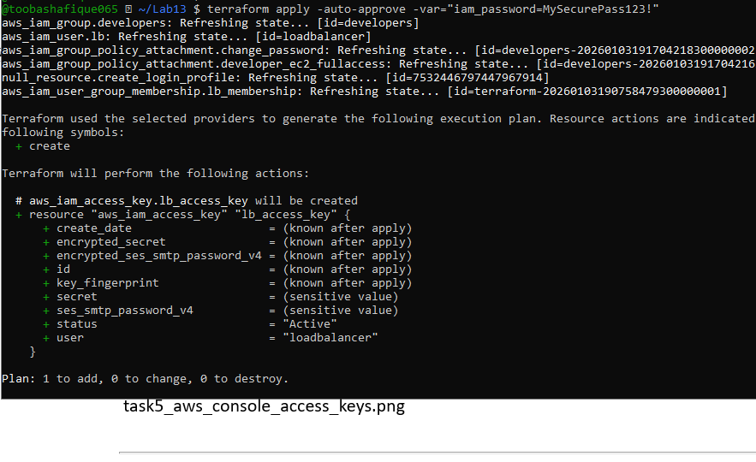
task5_terraform_output.png

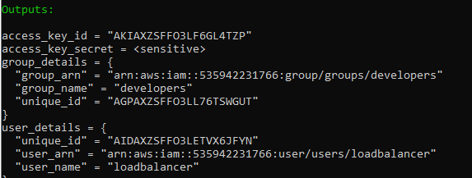
task5_tfstate_secret.png
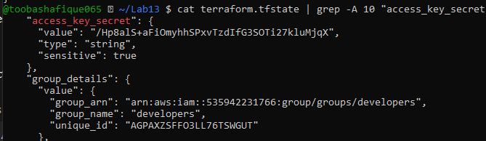
task5_aws_console_access_keys.png
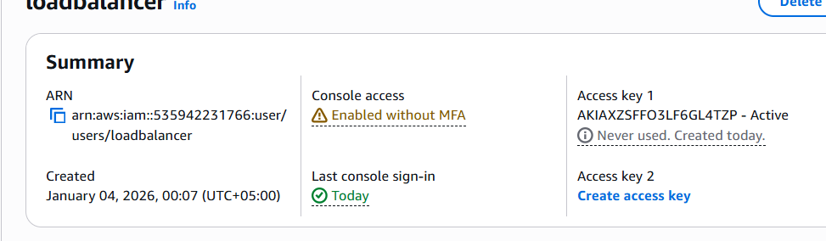

TASK 6 – Terraform Remote State (S3)
Screenshots
task6_s3_bucket_create.png
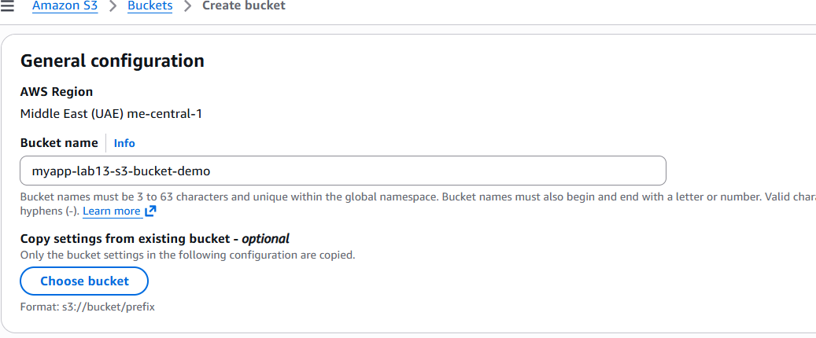
task6_s3_bucket_versioning.png
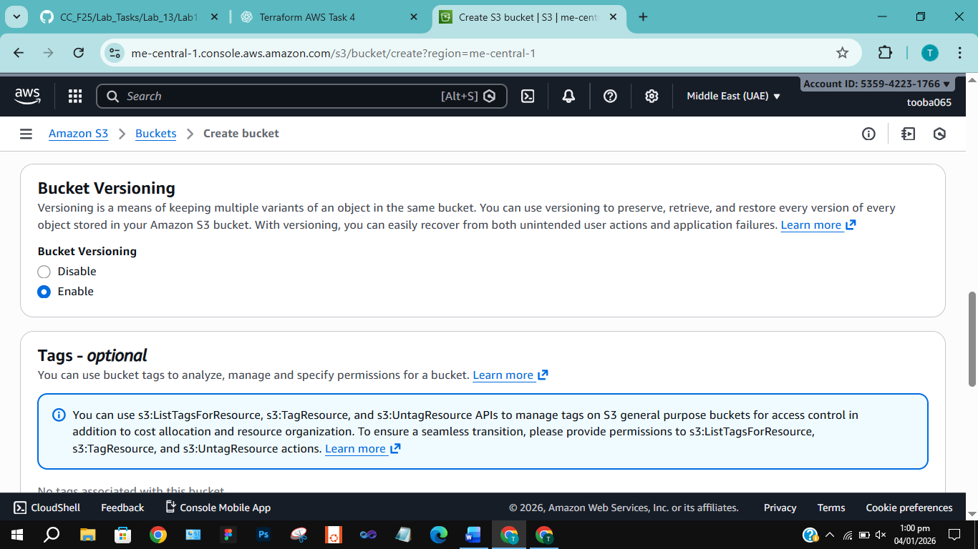
task6_main_tf_backend.png
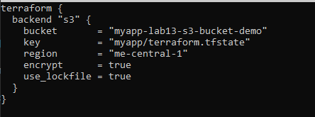
task6_terraform_init_migrate.png
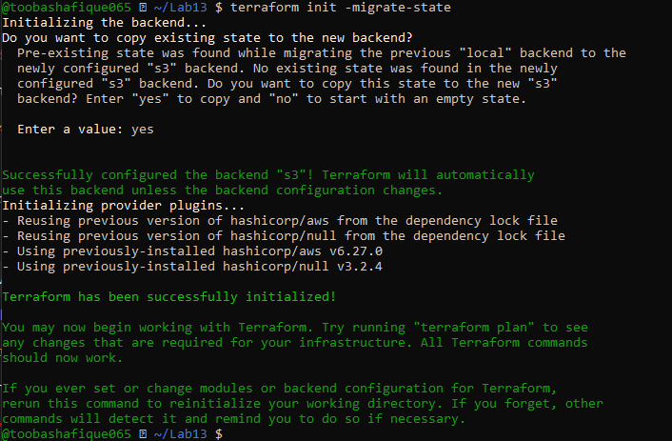
task6_terraform_apply.png
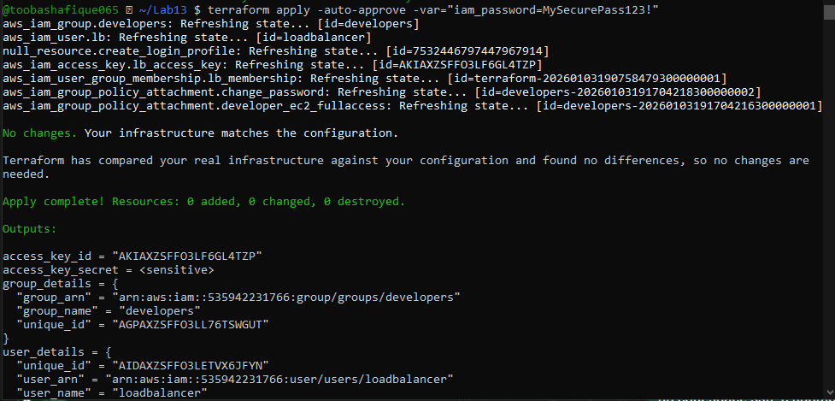
task6_s3_tfstate_file.png
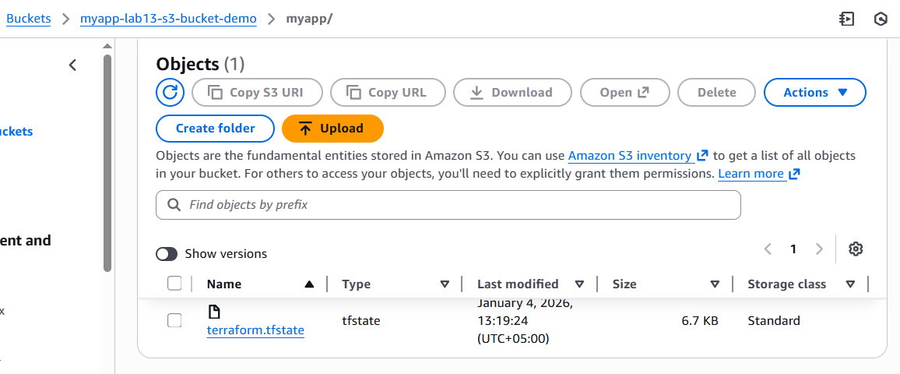
task6_local_state_backup.png
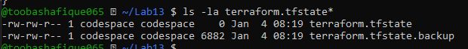
task6_terraform_destroy.png
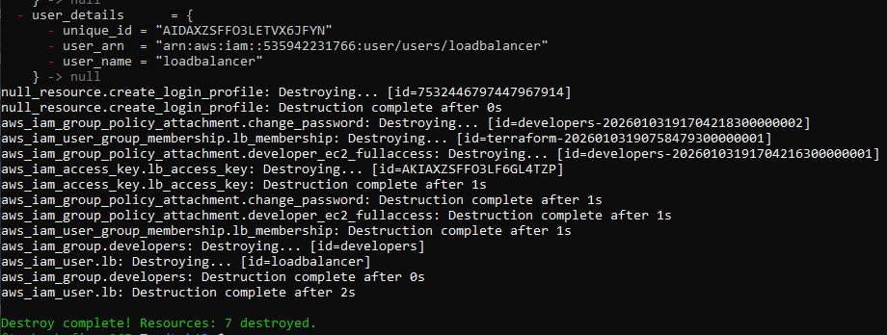
task6_s3_tfstate_destroyed.png
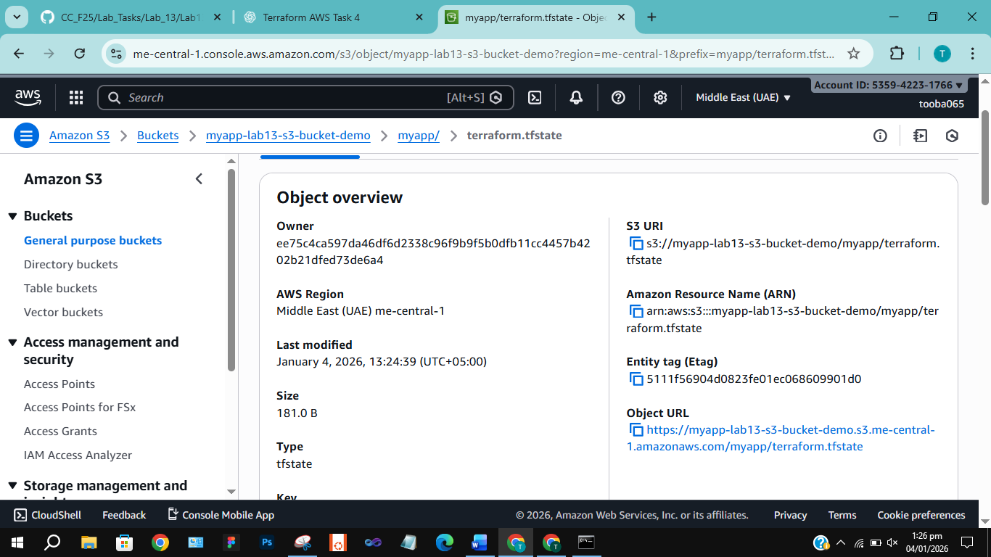

TASK 7 – Multiple Users via CSV
Screenshots
task7_locals_tf.png
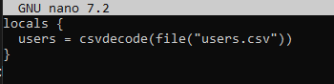
task7_users_csv.png
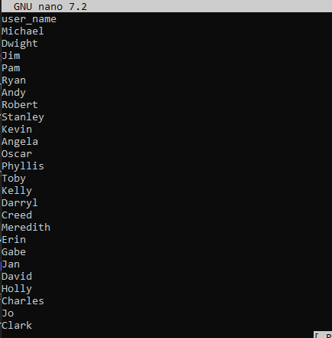
task7_main_tf_multiple_users.png
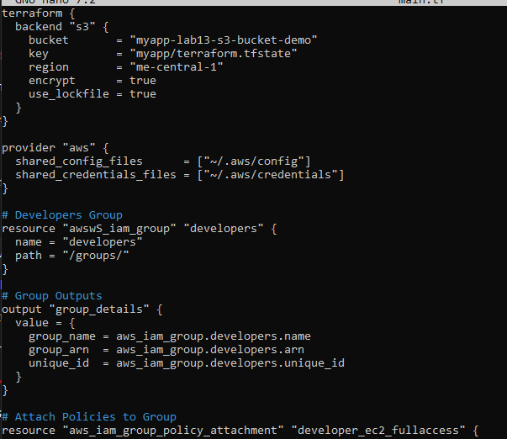
task7_terraform_init.png
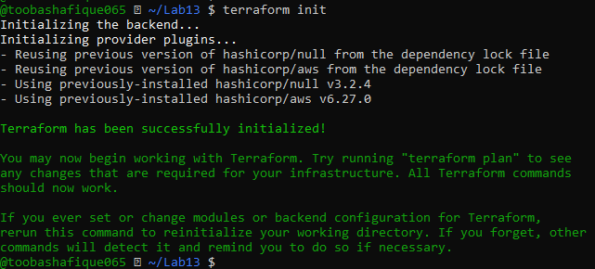
task7_terraform_apply.png
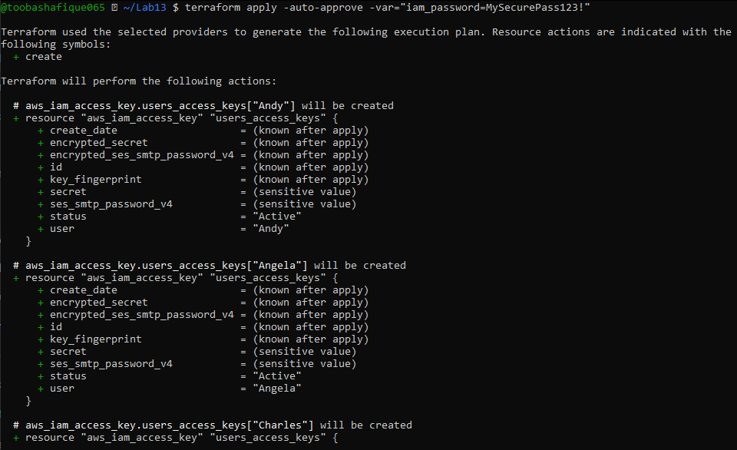
task7_terraform_output.png
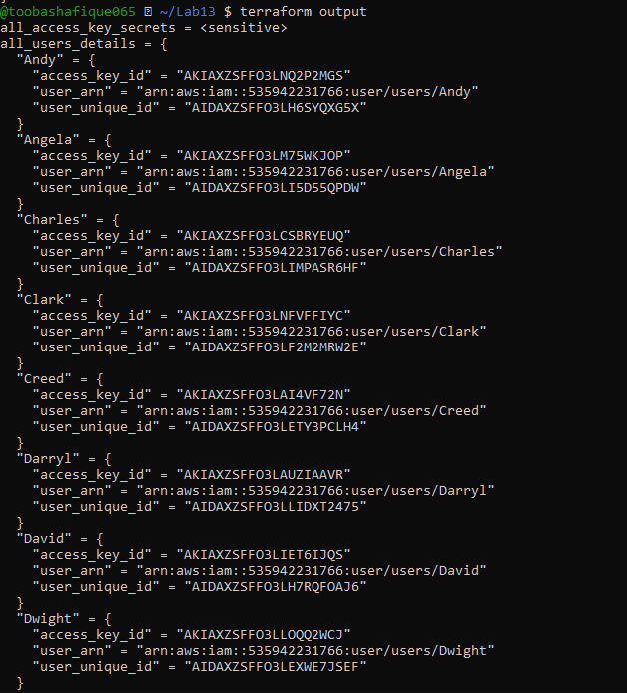
task7_tfstate_secrets.png
task7_aws_console_all_users.png
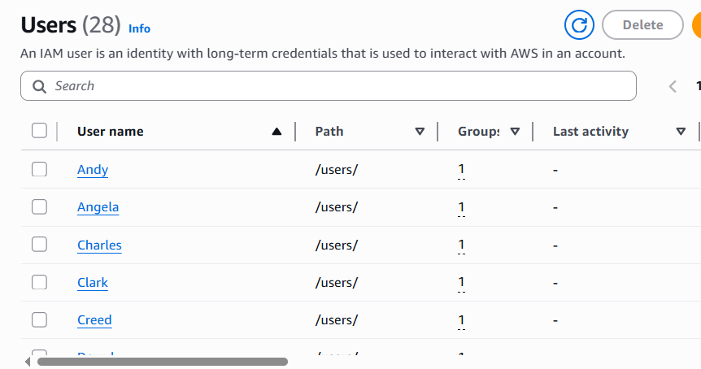
task7_aws_console_group_members.png
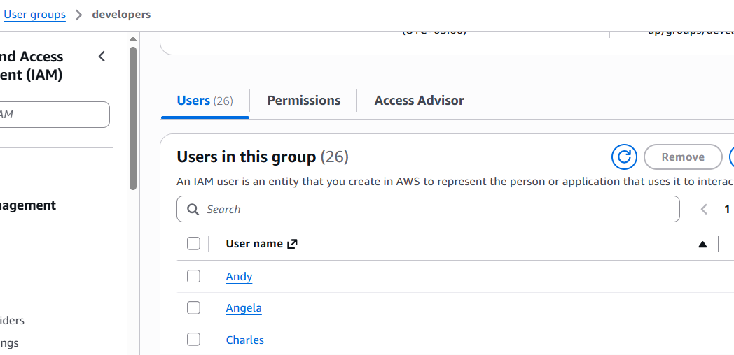
task7_aws_console_user_access_key.png
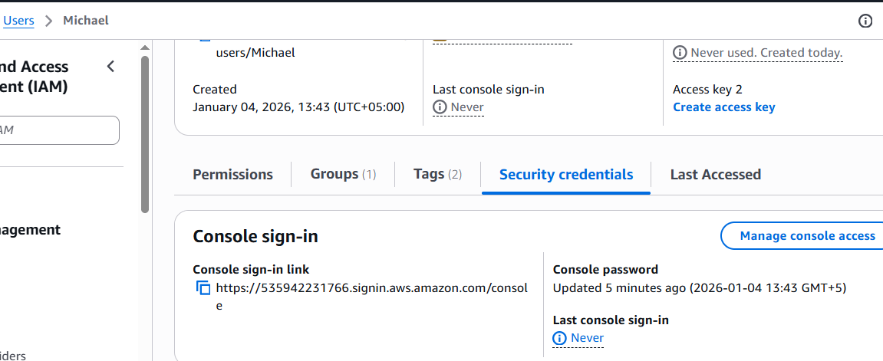
task7_s3_tfstate_multiple_users.png
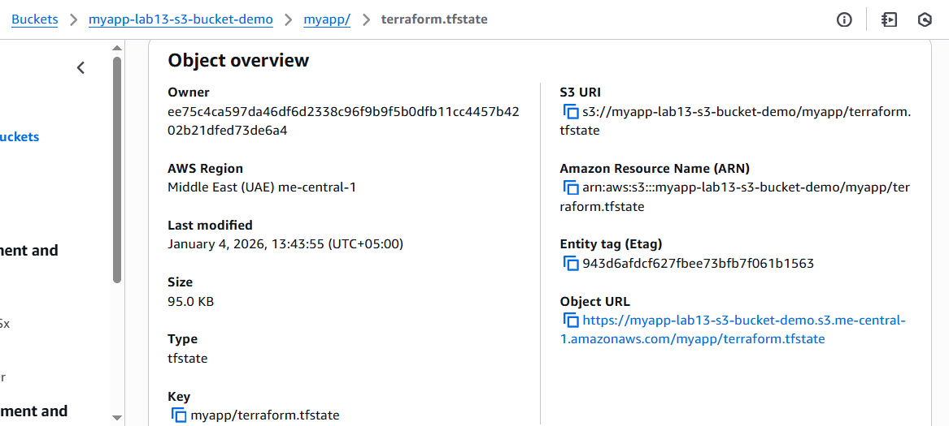

CLEANUP
Screenshots
cleanup_destroy_complete.png
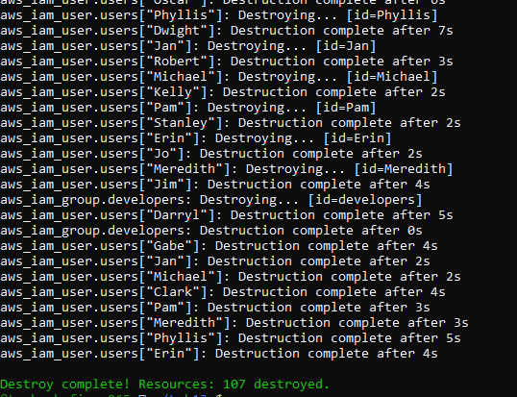
cleanup_aws_console_users_deleted.png
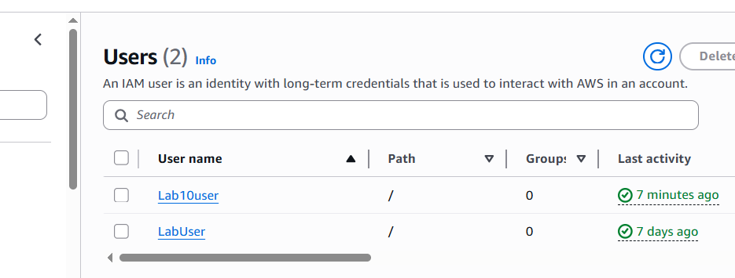
cleanup_aws_console_group_deleted.png
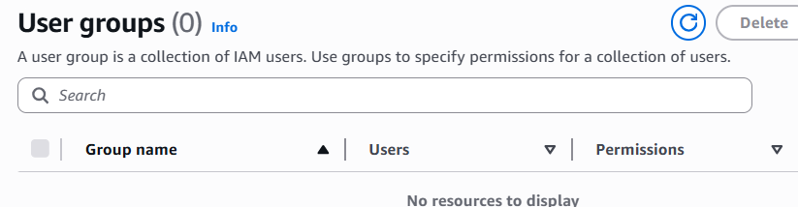
cleanup_s3_empty_state.png
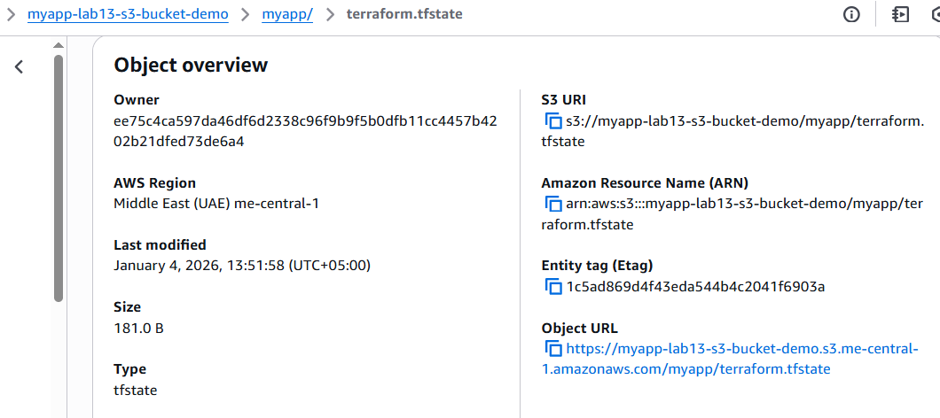
cleanup_final_files.png
